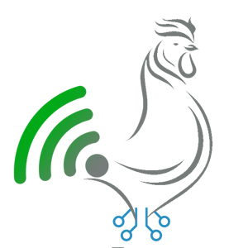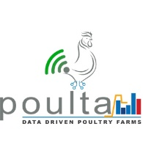

**Poulta Inc**

**Robotic solutions for**

**The Poultry Industry**

Table of Contents

1. Executive Summary 2

2. Scope Overview 2

3. Soil Moisture analysis: 3

Soil Conditions 3

4. Results 4

5. Future Roadmap 4

# Executive Summary

Poulta is based on industry 4.0 technologies, where modern and futuristic technological landscape is helping industries to reshape traditional businesses in new ways in term of Smart Poultry Industry.

Our services and products offered are tailor-made for your business’s specific needs. We are constantly improving our IoT solution portfolio with the help of our in-house team of hardware and software developers. Our solutions are focused on optimizing the costs, enhancing the efficiency, transforming the processes, managing the resources, improving the profitability & enhancing the visibility ultimately resulting in smooth and streamlined operations.

# Scope Overview

Poulta Smart Poultry Solution comprises of Hardware & Software. Hardware being the entity to collect the data and software hosted on cloud to process the data.

Our solution merges operations related to the real-time monitoring and surveillance of the birds by using Robots for Poultry farms, as per our visit to the AGRICULTURE UNIVERSITY Tando Jam we have identified our scope related to the solutions. Those solutions after having a discussion had been finalized along with the future roadmap.

# Robotic Solutions scope

We have studied and identified the following Robotic solutions for the poultry industry.

We have planned to use automatic and controllable tracking robots inside the poultry shed. Some examples of different tracking robot kits which can be used to build and be integrated to give real-time surveillance and monitoring of the Poultry farms are mentioned below:

# AlphaBot2 robot building kit for Raspberry Pi 3 Model B+:

Overview:

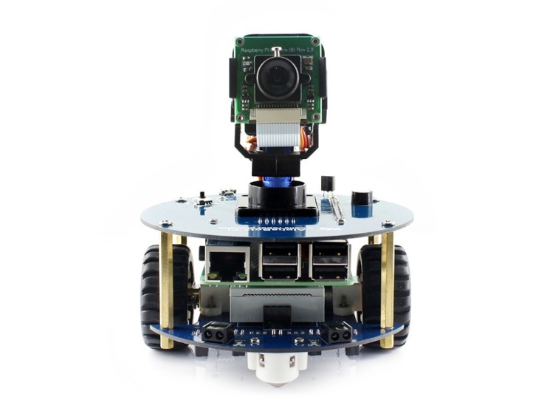This AlphaBot2 robot kit is designed to be used with Raspberry Pi 3 Model B+. It features rich common robot functions including line tracking, obstacle avoiding, Bluetooth/infrared/Wi-Fi remote control, video monitoring, etc.

Thanks to the highly integrated modular design, it is fairly easy to assemble by a snap, no soldering, and no wiring.

AlphaBot2 Features:

AlphaBot2 employs a 2-layer structure to provide excellent stability and compatibility.

**AlphaBot2-Base, the lower base chassis:**

* 5-ch infrared sensor, analog output, combined with PID algorithm, stable line tracking
* Onboard modules like line tracking, obstacle avoiding, needs no messy wiring
* TB6612FNG dual H-bridge motor driver, compared with L298P, it's more efficient, more compact, and less heating
* N20 micro gear motor, with metal gears, low noise, high accuracy
* Onboard RGB LEDs, true color lighting, pretty cool

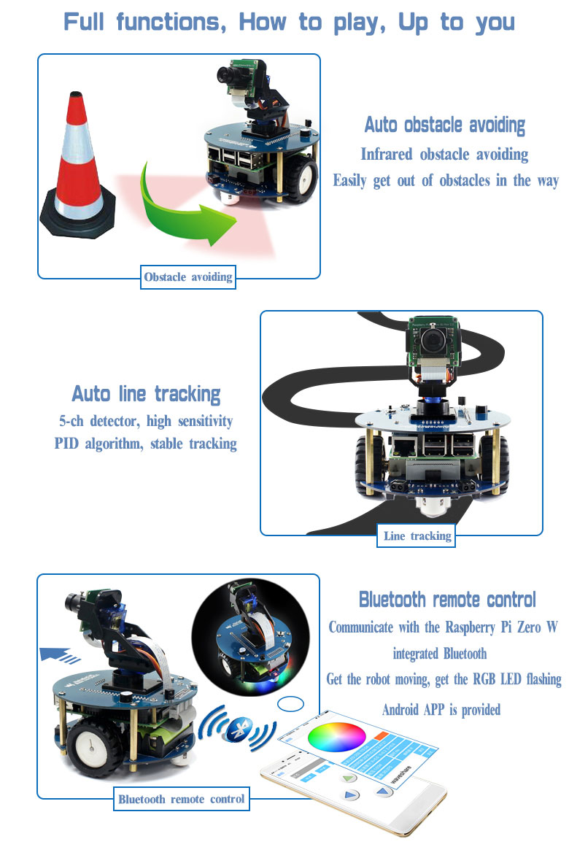

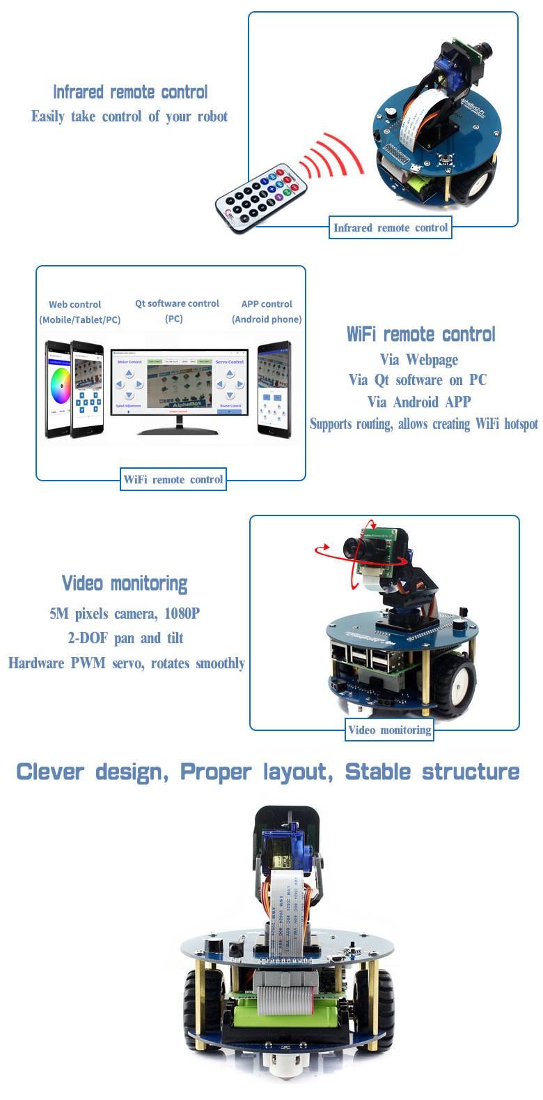

**Cost:** $119.99

Ref: <https://www.waveshare.com/alphabot2-pi3-b-plus.htm>

# Rasperino - Autonomous/Web Controlled Raspberry Pi & Arduino Robot kit

Overview:

This Robot kit includes a Raspberry Pi 3 B and consists of a Raspberry Pi Camera Module v2, an Arduino Uno, Power bank, an Arduino mobile platform and five sharp IR sensors. It can be efficiently used to track and navigate through maze like area autonomously, it can also detect colour signs and it is also able to give live video streaming through Wi-Fi over Desktop/Mobile device for real-time monitoring and surveillance which is ideal for our Robotic solution scope for Poultry farms.

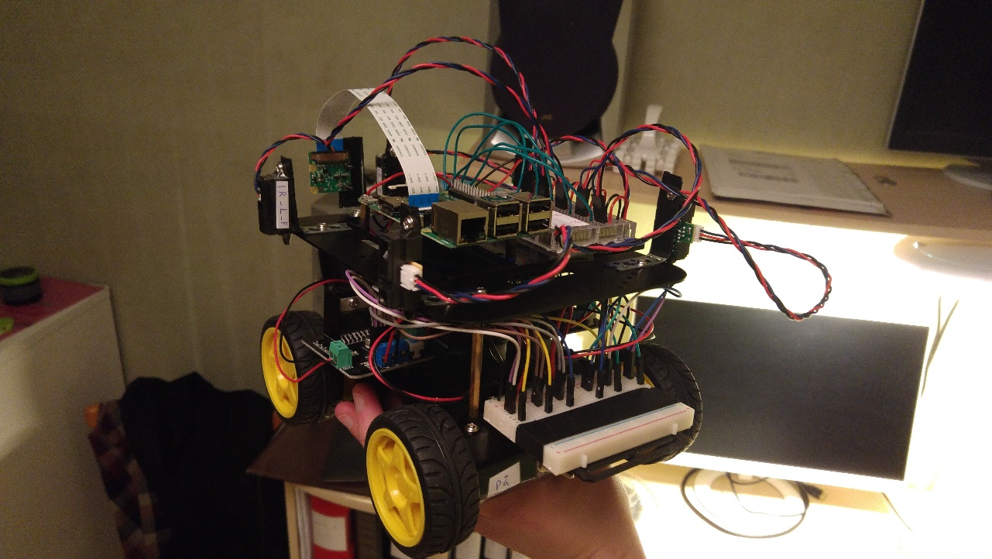

Features:

- Autonomous navigation of simple mazes.  
- Basic computer vision for detection of "color signs".  
- Video streaming. - Web interface for manual control and monitoring (desktop & mobile).  
- PD controller.

Functionality:

- The Arduino reads and filters the IR sensors, implements the PD controller, controls the motor controllers via PVM and runs a state machine for autonomous navigation.  
- The Raspberry Pi acts as a webserver, streams live video and runs a basic computer vision algorithm.  
- The Arduino sends sensor and status data to the Raspberry Pi over serial (USB cable), which in turn sends this (and video streaming data) to the web page over wifi.  
- User input is sent from the web page to the Raspberry Pi over wifi, which in turn sends this to the Arduino over serial.

Ref: <https://www.instructables.com/id/Rasperino-AutonomousWeb-Controlled-Raspberry-Pi-Ar/>

# Remote Control - Bluetooth – Arduino- PuTTy

Overview:

This method can be used to control any device remotely through Bluetooth by Arduino and it includes free software that allows you to control just about any electrical device from an LED all the way to 110 volt AC lamps, fans, etc.

Components:

* HC-06 or HC-05 Bluetooth Module
* Arduino Uno/Nano/Pro-Mini just to name a few
* Relay Module
* Bread Board
* 5 volt direct current source - I used a converted computer ATX power supply

For more details, please visit: <https://www.instructables.com/id/Remote-Control-Bluetooth-Arduino-PuTTY/>

# Future Roadmap

The above mentioned scope has been finalized and tested. Now, we have plans for updating our research and making improvements or any modifications if needed in the near future.

For the above mentioned scope amendments if there is required, will be done.